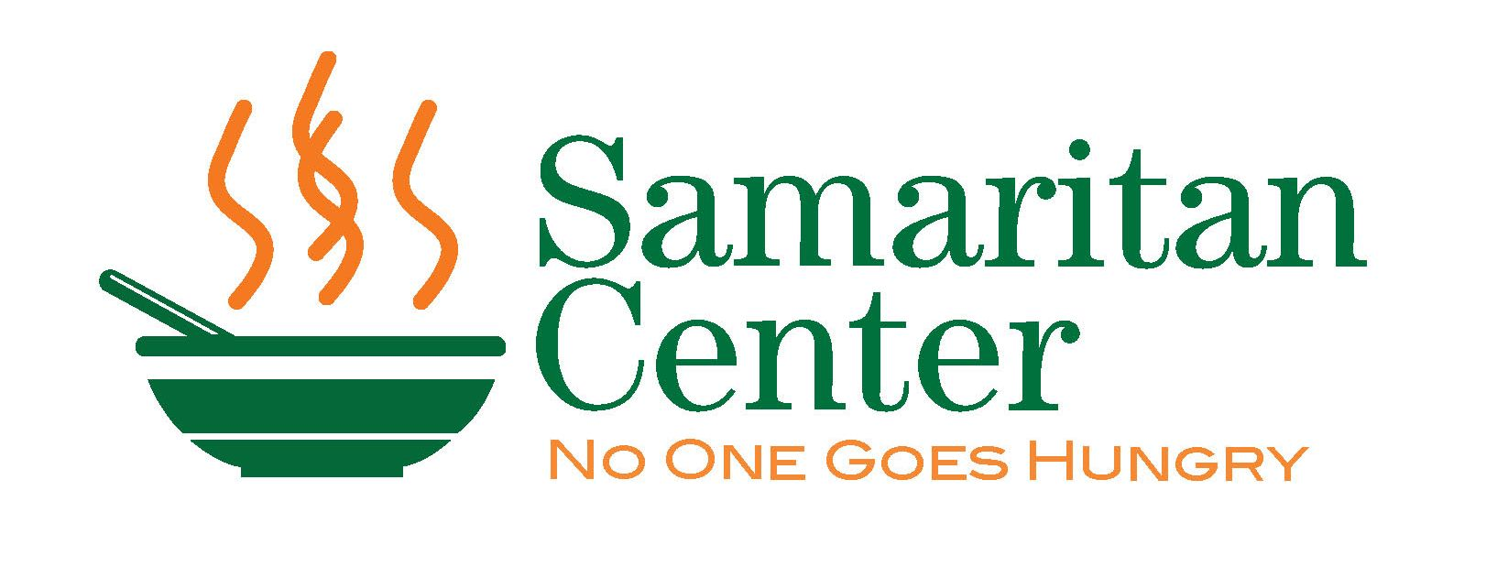
Annual Samaritan Center
Soup Bowl Open Golf Tournament

We are pleased to invite you to the 21st Annual Samaritan Center Soup Bowl Open Golf Tournament, which is being held on Monday, July 29th, 2024. Through your participation in this tournament, we hope to raise over $40,000 to support the Samaritan Center.

More than 40 years ago, Samaritan Center began fighting hunger in the greater Syracuse community by providing hot, nutritious meals to anyone in need seven days a week – no questions asked. Paired with these meals are case management support and access to services that help our guests move on to a more positive future.

Here’s a quick look at us by the numbers:
365 | Days a year we serve meals
1500 | Volunteers per month
100,000 | Meals served each year
51,870 | Basic needs items distributed in 2023
$1.88 | Cost to provide a hot, nutritious meal
100 | Percentage of staff and volunteers who give their whole heart to our guests

The Samaritan Center relies on the generosity of individuals and corporate partners for more than 90% of its funding. Fundraising events like the Soup Bowl Open ensure that we are able to meet the needs of each guests. Below are some quick details about the tournament.

- Tuscarora Golf Club, Marcellus, NY
- Monday, July 29th. 2024
- Registration and lunch starting at 11:30 am
- Use of the driving range and practice facilities
- Shotgun start 12:30 pm
- Four-person captain and crew
- Dinner immediately after golf
- Long drive, closest to the pin, hole in-one, team prizes and raffle prizes

To register, please return the registration page of this letter along with your check made payable to The Samaritan Center. Please respond by June 28th, as space is filled on a first come, first serve basis. Your payment will serve as your registration confirmation. For more information, please call the Samaritan Center at 315-472-0650 ext. 208. The Samaritan Center is a tax-exempt organization.

We look forward to seeing you on July 29th, 2024!

Kindest regards,

The Samaritan Center Soup Bowl Committee
Annual Soup Bowl Open Golf Tournament

Monday July 29th, 2024
To reserve a spot/team, please send this registration form by June 28th with a check made payable to The Samaritan Center. The earlier you return this form with your payment the more likely you are to assure yourself/team a spot in this year’s tournament. We register teams on a first come, first served and we will cut-off registrations at 32 teams.

Name: ________________________________________________________________________________
Company: ________________________________________________________________________________

Address: ________________________________________________________________________________

Email Address: _____________________________________________________ Phone #: ___________________
Double Eagle Sponsor – Your company receives a foursome in the event - please complete team names on the back of this form; two hole sponsorships; your company’s banner displayed at the event; listing on the program, Samaritan newsletter, web page and marketing materials; table cards displaying your logo on each dining table at lunch and dinner; ability to display company materials at the event and special recognition at lunch and dinner. | $3,500
Eagle Sponsor- Your company receives a foursome in the event – please complete team names on the back of this form; a hole sponsorship; listing in the event program; Samaritan newsletter, web page and marketing materials. | $2,500
Welcome Gift Sponsor – Your company’s logo printed on the welcome gift distributed to registered players the day of the event. | $3,000
Cart Sponsor - Your company receives one hole sponsorship; your logo displayed on each cart during the tournament; listing in the event program and on the web page | $2,000
Dinner or Lunch Sponsor - Your company receives a hole sponsorship; your company’s logo displayed during dinner or lunch; table cards displaying your logo on each dining table; listing in the program and on web page and special recognition at dinner or lunch. | $1,500
Business Sponsor – Your company receives a hole sponsorship and a foursome registration with lunch and dinner included for each participant. Name included on event program. Please complete team names on the back of this form. | $1,250
Captain a Foursome -. Your company receives a foursome registration – please list team names on the back of this form; lunch and dinner included for each participant. | $800
Tee Sponsor– Your company’s name or logo displayed on a hole sponsor on the golf course and listed in the event program. | $300
Individual Golfer Registration - Individual registration with lunch and dinner included. | $200
Donation –Sorry I’m unable to make it but I would like to donate unrestricted funds to help underwrite the costs of the golf tournament. | $______
 | Total

If you plan to captain a foursome, please list the names, addresses and phone numbers of the members of your foursome below. If spots are unfilled but you plan to fill them before the tournament, mark in the name space(s) “TBA”. If you’d like us to help fill your foursome, mark the name space(s) “HELP”.

Name | Address and Email Address | Phone Number
1.
2.
3.
4.

Please mail this form along with your check payable to The Samaritan Center – 215 N. State Street, Syracuse NY, 13203 www. samcenter.org - 315-472-0650 or complete payment information below.
Your payment will serve as your registration confirmation.

Name on Credit card ___________________________________________________________
Credit Card number____________________________________________________________
Expiration________________ CVC Code_______________________ Zip Code_____________

Thank you for your support!!

We are a non-profit 501C3 and your donation is tax deductible as allowable by law. Our EIN Number is 16-1328786. A copy of Organization's latest annual financial report may be obtained, upon request from the Samaritan Center: 215 N. State St., Syracuse, NY 13203 or from the NYS Attorney General's Charities Bureau: 120 Broadway, 3rd Floor, NY, NY 10271.

